 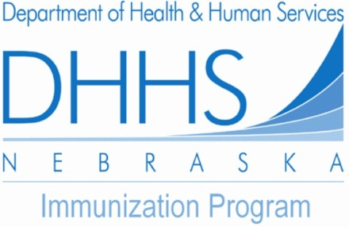

Nebraska Immunization Information System (**NESIIS**)

*User Enrollment and Training Request*

(Please Print or Type)

**Organization / Clinic Name:**

Type of Facility:

        

**Organization/ Clinic**

Address:

Physical Address (No P.O. Boxes)

Mailing Address

City State Zip

**Clinic Main Telephone:**

**Primary Contact Person:**

First Name Last Name Title

**Email address:**

**Telephone: Ext: Fax:**

Does your facility have an EMR:

 



Nebraska Immunization Information System (**NESIIS**)

*User Enrollment and Training Request*

*Additional Trainees*

**Clinic name:**

|  |  |  |  |  |  |
| --- | --- | --- | --- | --- | --- |
|  | **Last Name** | **First Name** | **Middle Initial** | **Email** | **NESIIS Security Role** |
| 1 |  |  |  |  |  |
| 2 |  |  |  |  |  |
| 3 |  |  |  |  |  |
| 4 |  |  |  |  |  |
| 5 |  |  |  |  |  |
| 6 |  |  |  |  |  |
| 7 |  |  |  |  |  |
| 8 |  |  |  |  |  |
| 9 |  |  |  |  |  |
| 10 |  |  |  |  |  |
| 11 |  |  |  |  |  |
| 12 |  |  |  |  |  |
| 13 |  |  |  |  |  |
| 14 |  |  |  |  |  |
| 15 |  |  |  |  |  |

Please send the completed forms by any of the following:

**Email**:

[dhhs.nesiis@nebraska.gov](mailto:dhhs.nesiis@nebraska.gov)

**Fax:**

(402) 471 – 6426

**Mail:**

NDHHS

Immunization Program

P.O. Box 95026

Lincoln, NE 68509-5026

Additional Questions please contact our Help Desk at: **1-888-433-2510**

***NESIIS Role Types****:*

***A = Administrator*** *(Manages site inventory/ Set up Physicians and Clinicians Accounts)*

***T = Typical User*** *(Enters Patient and Immunization Data, Runs Reports, NO Inventory Control)*

***Q = Query User*** *(Allows Viewing Only)*

***S = School Nurse*** *(Allows Viewing of Records and Monitoring of Students)*

***DE = Data Exchange*** *(Submits/ Receives Files via NESIIS Data Exchange Process)*