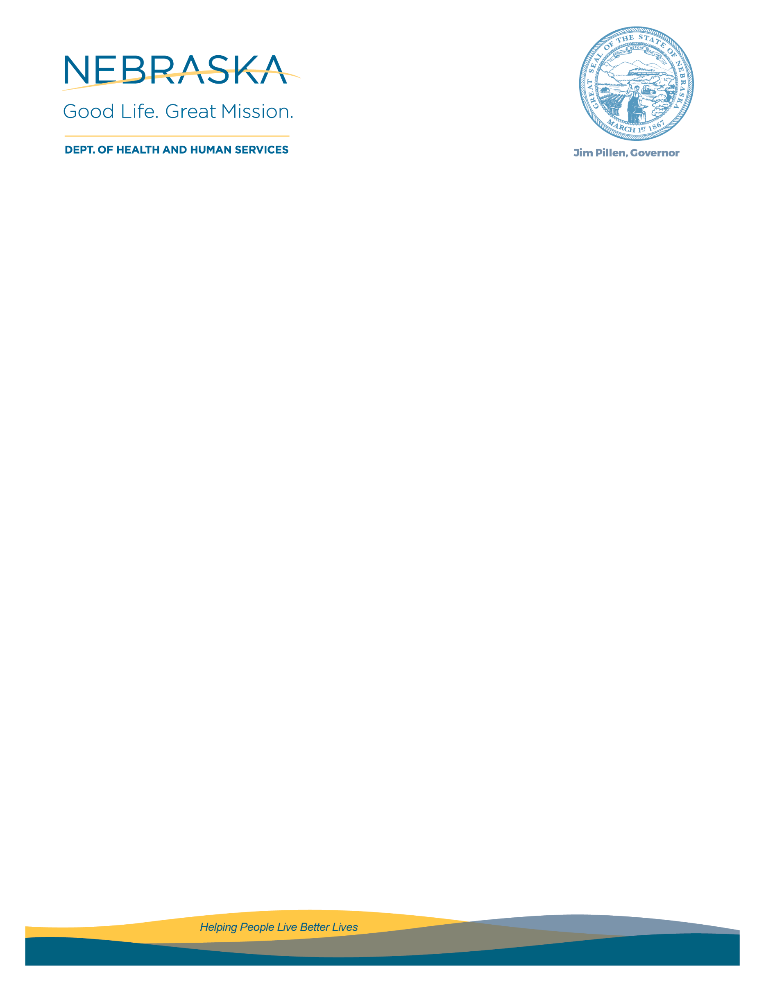

FORM 5 – PERFORMANCE OUTCOMES

NHAP reviews performance measurements to demonstrate subrecipient outcomes. Outcomes assist in measuring program progress and in demonstrating that the defined goals and objectives for SOAR funding are being met.

2024-25 For Previous SOAR Grantees Only:
All Applicants that have received funding to support SOAR services during the July 1, 2024 – June 30, 2025, program year must complete the below Performance Outcomes. Provide justification for all performance metrics not met during the previous grant agreement.

For Applicants that have previously received SOAR funding, but not during the 2022-23 program year, complete the tables below regarding the most recent Grant-funded year. If performance metrics were not met, provide justification for all metrics not met during the applicable Grant term.

Initial Applications
# of SSI/SSDI Initial Applications Filed
# of SSI/SSDI Applications Approved
% of SSI/SSDI Initial Applications Approved
Average # of Days to Initial Decision

Appeals
# of SSI/SSDI Appeals
% of SSI/SSDI Appeals Approved
Average # of Days to Appeal Decision

Referred Clients
# of clients referred to the agency for SOAR services
# of referred clients that met the eligibility criteria for SOAR services
# of referred clients that were eligible for services but were placed on a waiting list for assistance

Reflecting on the 2024-25 SOAR grant program year:

- What challenges were experienced?
- What new best practices were implemented?

New SOAR Applicants Only:

- For Applicants that have not previously received SOAR funding or completed a full program year, describe experience and outcomes relevant to this project.

