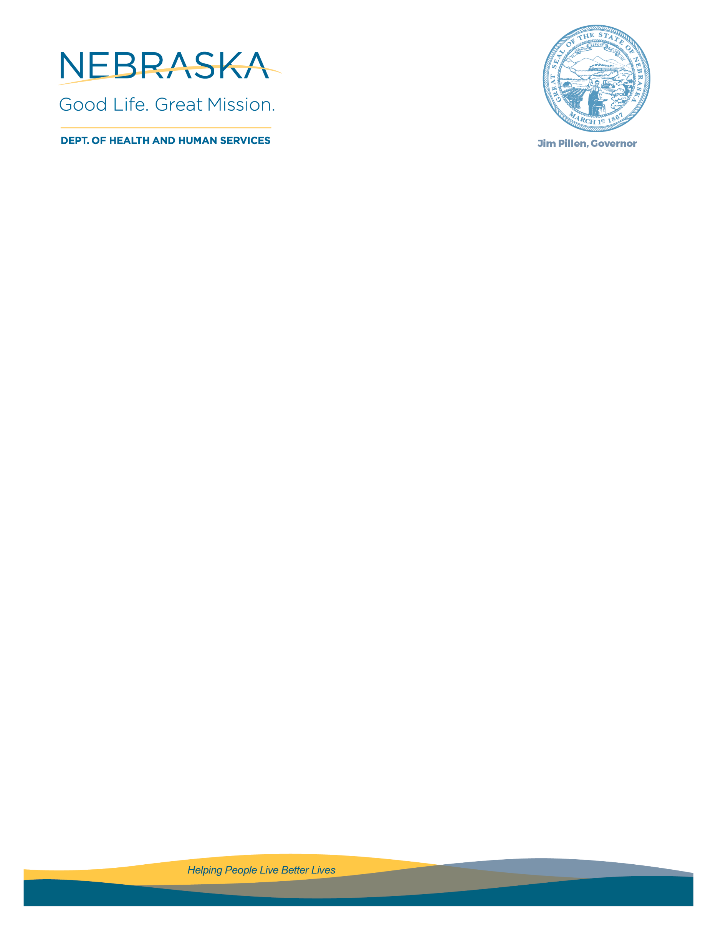

FORM 2 – APPLICANT’S ORGANIZATIONAL OVERVIEW
The Applicant’s Organizational Overview shall contain the following information about the Applicant. If the Application is a cooperative or joint venture between two or more entities, all information required in this section shall be provided for all entities, even if a new legal entity has been created or is planned to be created for the purposes of the Grant.

- Organization Information. Applicant’s full legal name, including any other “doing business as” names, or any previous names the organization used.

- Summary of State and Federal Grants Experience. A description of the Applicant’s previous experience with receiving state or federal funds. This shall include, but not be limited to, experience receiving state or federal funds as a recipient or a Grantee. The Applicant should describe and demonstrate knowledge of the Uniform Grant Guidance, as well as any specific experience with the particular state program and funding source that funds this RFA.

- Summary of Programmatic Experience. A description of the Applicant’s experience with the type of
programming or work contained in the Project Description or other relevant work.

- Personnel and Management. The Applicant should identify individuals employed by the Applicant, on its board of directors, or otherwise affiliated with the Applicant, who have a demonstrated knowledge or
experience with federal or state grants, the Uniform Grant Guidance, programmatic experience, or other relevant experience.

- Agreements Terminated or Costs Disallowed. Applicant must provide a summary of any agreements executed within the last five (5) years with federal awarding agencies or pass-through entities (either as grant agreements, cooperative agreements, subawards, or contracts) that:
o Were terminated for cause; or,
o Where Specific Conditions were placed on the Applicant (see 2 CFR § 200.207 or 45 CFR §
75.207).

If an Applicant has been disbarred by the United States Federal government, it is not eligible to receive funding under this RFA.

