**Attachment 1 – End User Guidance: Shared File Link**

**STEP 1:**

Click the URL link to the ShareFile folder.

Enter the required information and Click “Continue” button.

ShareFile works with Firefox, Internet Explorer, and Chrome web browsers. **ShareFile does not work with Microsoft Edge.**

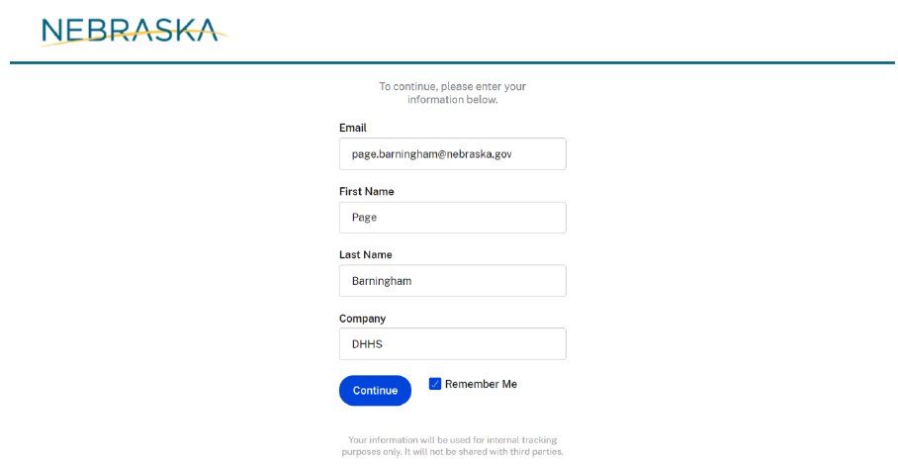

**STEP 2:**

Upload or drag files to upload them.

Applicants should clearly identify the uploaded response files. To assist in identification please use the following naming convention: **RFA XXXX ABC Company**

If multiple files are submitted for one funding opportunity, add number of files to file names: **RFA XXXX ABC Company File 1 of 2**

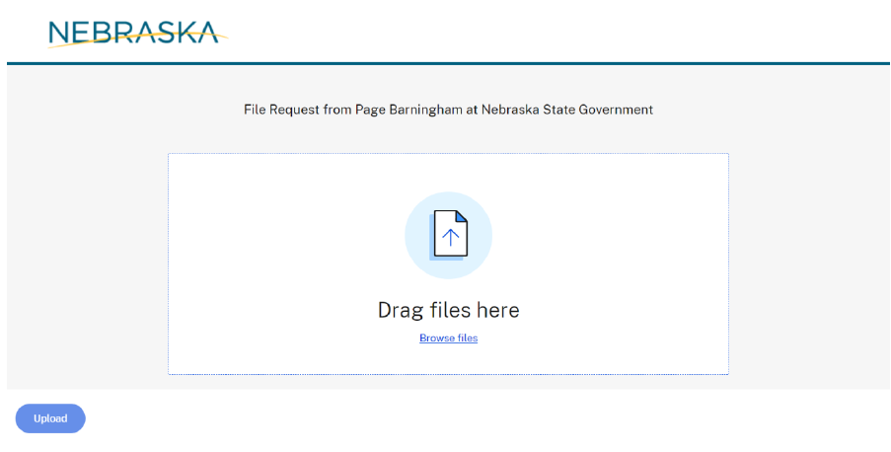

**STEP 3:**

Verify and submit loaded documents.

Click the “Upload” button to submit.

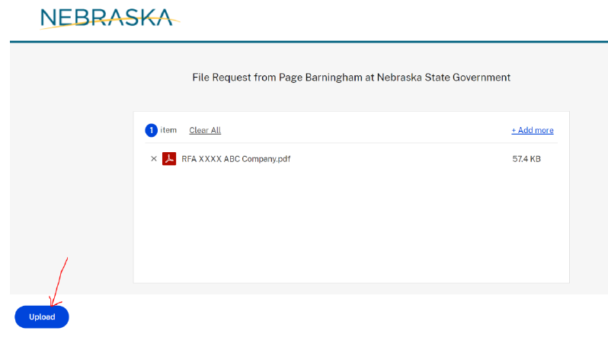

An uploaded document will show up as “Uploaded” in green highlight on the screen.

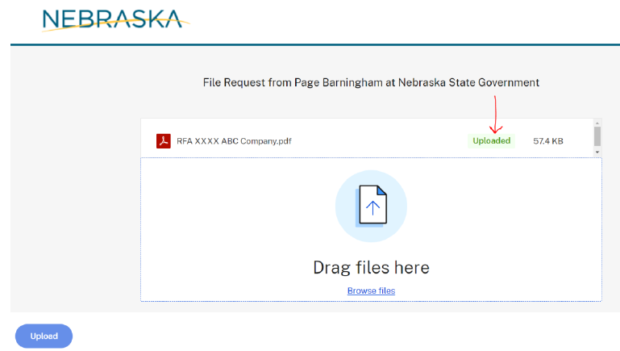

**STEP 4:**

Verify the file has Uploaded successfully.

The system will generate a confirmation of the upload to be sent to the email address that was entered in STEP 1.

If you do not receive this confirmation, your file may not have been received.

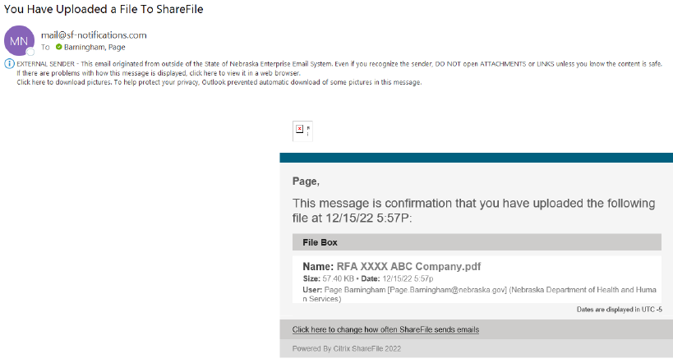

Assistance with technical issues can be found at https://www.sharefile.com/support