LA Name: ___________________________ FY 2018 Action Plan
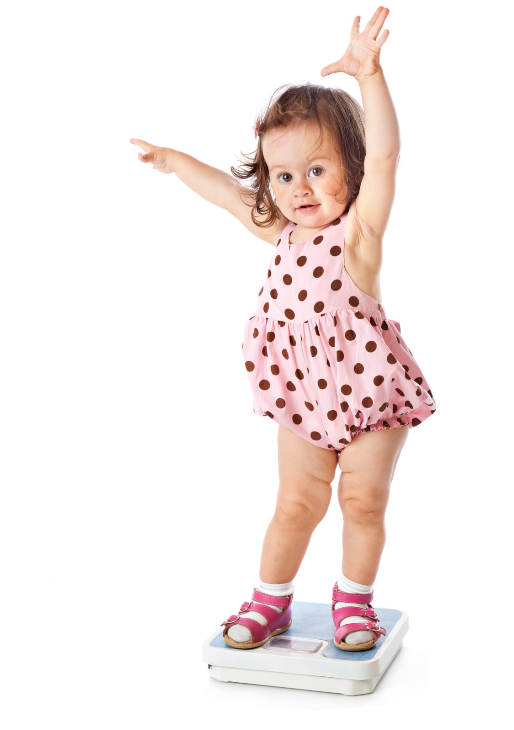
NUTRITION GOAL

JOINT NUTRITION/OBESITY GOAL: By October 1st, 2019, the percentage of WIC children ages 2-5 who are overweight/obese will be less
than or equal to 18%.

Data Source: Query of Nutrition Risk Report (113 obese, 114 overweight)
LOCAL AGENCY – PROGRESS DATA
 | Children with risk 113, 114 | Total children 2-5 | Total % of children Overweight/Obese risk
Baseline
2016

Progress
2017

STATE – PROGRESS DATA
 | children risk  113, 114 | Total children 2-5 | Total % of children Overweight/Obese risk
Baseline  2016 | 6,508 | 23,938 | 27.2%
Progress  2017 | 6,184 | 24,480 | 25.3%

JOINT STRATEGY #1: Support the role of WIC in preventing childhood overweight and obesity for WIC participants, within the ages of 2-5.

ACTION STEPS: (what & why) | WHO: | WHEN: | SPECIAL NOTES:
Evaluation Methods will be:

Add additional rows as needed

