MENTAL HEALTH GOAL
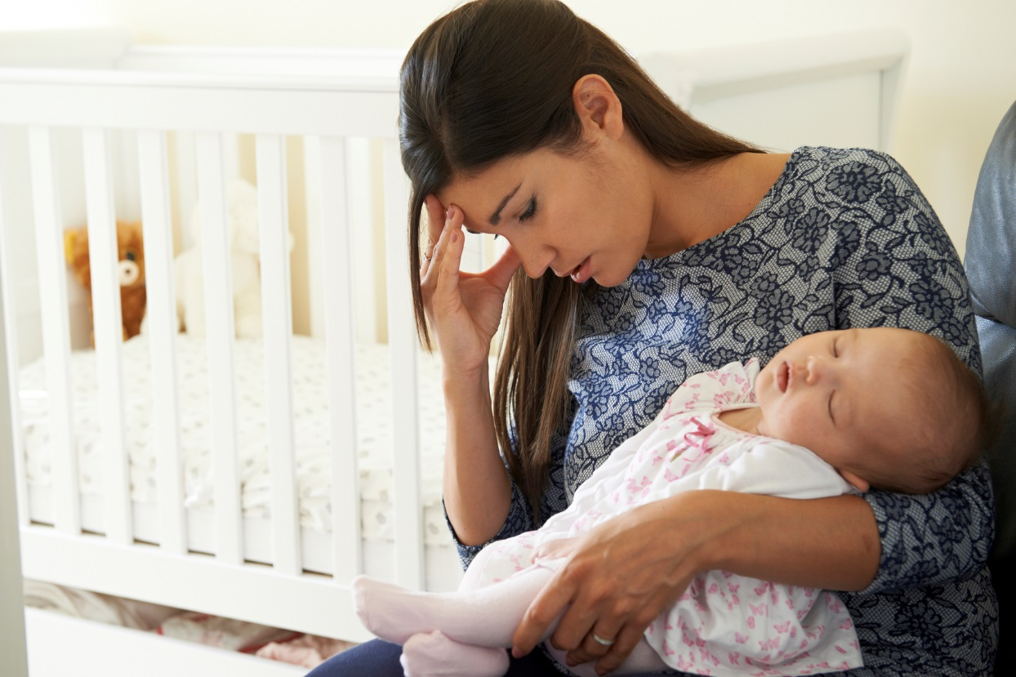

FY 2019 Action Plan

Mental Health Joint Goal: By October 1, 2019, increase the percentage of mental health referrals by 25%.

Data Source: Journey referral summary report using newly created referral code
LOCAL AGENCY DATA
Total # Referrals to mental health provider
June 2016 – June 2017
June 2017 – June 2018

STATE DATA
 | Total # Referrals to mental health provider
June 2016 – June 2017 | 227
June 2017 – June 2018 | 297

JOINT STRATEGY #1: Implement a maternal mental health screening, referral and education policy/process.

ACTION STEPS: (what & why) | WHO: | WHEN: | SPECIAL NOTES:
EVALUATION METHODS:
Add additional rows as needed

