LA Name: FY 2018 Action Plan
EXCLUSIVE BF GOAL
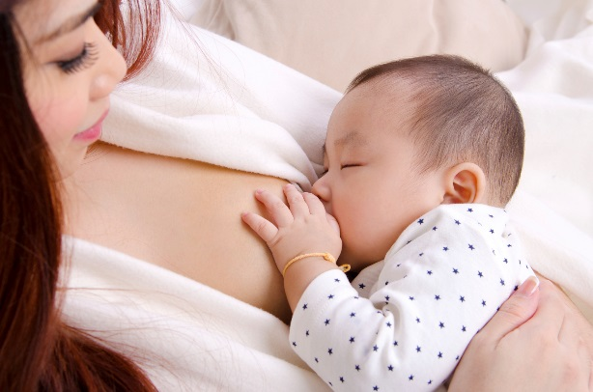

Joint Breastfeeding Goal:
By October 1st, 2019, the percentage of WIC infants who are exclusively breastfed at 6 months of age, will be greater than or equal to 20%.

Data Source: Journey Breastfeeding Prevalence Report
STATE – PROGRESS DATA
Date | % infants ever BF | % infants exclusively BF  at 1 week | % infants exclusively BF at 3 months | % infants exclusively BF at 6 months
June 2016 (baseline) | 78% | 46% | 17% | 9%
June 2017 | 80% | 44% | 16% | 9%
June 2018 | 81% | 43% | 15% | 8%

LOCAL AGENCY – PROGRESS DATA
 | % infants ever BF | % infants exclusively BF  at 1 week | % infants exclusively BF at 3 months | % infants exclusively BF at 6 months
June 2016
baseline
June 2017
June 2018

JOINT STRATEGY #1: Promote and support exclusive breastfeeding for all WIC mothers and their infants.

ACTION STEPS: (what & why) | WHO: | WHEN: | SPECIAL NOTES:

JOINT STRATEGY #2: Incorporate Breastfeeding Backpack initiative to educate and encourage mothers to exclusively breastfeed for the first 6 months.
EXCLUSIVE BF GOAL

ACTION STEPS: (what & why) | WHO: | WHEN: | SPECIAL NOTES:
Evaluation Methods will be:

Add additional pages if needed

