Appendix A: Current Environment Overview
The following subsections provide an overview of the current technical environment.

N-FOCUS – Nebraska’s Legacy Integrated Health and Human Services and Benefits Application
Nebraska Family Online Client User System (N-FOCUS) is an integrated system that automates benefit/service delivery and case management for more than 30 DHHS programs, including Aid to Dependent Children (ADC), Supplemental Nutrition Assistance Program (SNAP), Child Welfare and Medicaid. The system was initially developed in partnership with Accenture as the prime Systems Integrator. N-FOCUS functions include client/case intake, eligibility determination, case management, service authorization, benefit payments, claims processing and payments, provider contract management, interfacing with other private, state and federal organizations, and management and government reporting. N-FOCUS was implemented in production in mid-1996 and is operational statewide.
The typical N-FOCUS user is a DHHS or contracted employee. N-FOCUS supports over 2500 workers, operating from offices around the State as well as from 4 customer service centers and a centralized scanning facility. Some cases are assigned to specific workers; however, the majority of cases are managed via a universal caseload methodology coordinated by the customer service centers.
N-FOCUS has both batch and online components and stores data in Db2 and SQL Server. The Db2 database has over 650 tables, some with a corresponding archive table. There are over 785 relationships between tables, 1278 indexes, and over 9665 attributes. There are over 1.7 billion rows of production data with over 193 million rows in one table with an average table size of 3.2 million rows.
- Core Medicaid Enterprise System
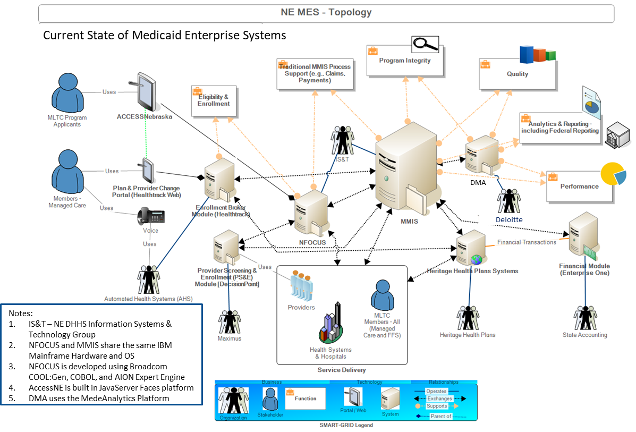
The batch system is coded in Z/OS COBOL and executes in a Z/OS environment. There are more than 660 procedures, over 850 programs, and over 375 stored procedures. The application generates over 800 reports using Crystal Reports that are published to a web portal through Business Objects Enterprise software. Another 100 reports generated independently are published to the portal for viewing.
The online system is an integrated client/server architecture software system. The client software executes on Windows 7/10 and resides on Windows 2008/2012 servers located throughout the State. Broadcom CA Gen (originally the Texas Instrument Information Engineering Facility Computer Aided Software Engineering Tool – TI IEF Case tool) and CA AION (Legacy Business Rules Engine and Expert System – AION to AICorp/Trinzic to Platinum to CA) toolsets are used to generate COBOL and C code, along with custom in-house architecture code written in C. The server components are Z/OS CICS transactions. The CICS programs are Gen-generated COBOL, along with in-house written COBOL and Assembler externals. The CICS programs access Db2 on the Z/OS mainframe. The Gen clients use External Call Interface (ECI), IBM’s CICS Universal Client to connect to the Z/OS CICS using TCP/IP protocol. The Gen online system consists of over 660 client procedures, 650 server procedures, 630 windows, and 1540 dialog boxes. The AION online system supports the complex eligibility data gathering and automated determination and noticing processes.
N-FOCUS web applications consist of public applications, including dashboard applications, and applications launched directly from N-FOCUS. Eclipse is the integrated development environment (IDE) used to generate the Java Server Faces and Facelets code. These Java applications run on Tomcat application servers on the Linux Operating System. The Java applications call stored procedures to access Db2 data and SQL to access SQL server data.
The primary role of the N-FOCUS team today is to maintain and enhance the N-FOCUS application. This includes providing users with technical and business support to keep the system current with government policy and industry technology, both of which continue to change at a rapid pace. The N-FOCUS team works in the Golds Building in Lincoln. Business and technical contract and full-time State team members are organized into teams that are involved in application development (Gen, AION, COBOL, Web, Batch), technical architecture (workstation communications, mainframe communications, print architecture, reporting architecture administration, document imaging administration), database administration, configuration management, project management, business requirements and testing, application and production support, and training. Approximately 35 technical and 30 business team members are assigned to the N-FOCUS team.
N-FOCUS is one of the largest integrated systems in the government of the State of Nebraska. Other significant systems within DHHS include Vital Statistics (management of birth, death, marriage, and other vital records for Nebraskans), CHARTS (management of child support enforcement operations), and MMIS (management of Medicaid-related provider/consumer claims and payments). While not an exhaustive list, Figure 2 (below) shows approximately 40 of the most significant interfaces between N-FOCUS and private, state, local, and federal partners. It should be noted that a large proportion of these interfaces are shared among multiple HHS program areas.
- N-FOCUS System Context Diagram and Key Interfaces

Current Application Architecture Components

Workstation Overview
The N-FOCUS client currently runs on workstations using the Windows 10 operating systems. N-FOCUS workstation client software architecture consists of several application layers. These layers include:
- Presentation services – The presentation services component is the Graphical User Interface (GUI) provided to the user. The presentation service is provided via a Windows workstation.
- Business rule services – These services provide the application business logic unique to each functional area. At the workstation, both early verification (using the GUI business rules) and late verification use application rules to provide accurate information.
- Security services – All traffic between N-FOCUS workstations and host applications are not yet encrypted prior to transmission over the network and to the host.
- Transaction services – Data traveling between the workstation and the host is organized into packets or transactions. The transaction services component creates data transactions and transports the information to and from the host. The infrastructure supporting this is based on IBM’s n-tier Customer Information Control System architecture. CICS components in the user workstation communicate to the back-end CICS component on the mainframe.

Server Overview
- Local file servers - The local file server is used as a staging area for software distribution to reduce bandwidth congestion. Rather than distributing new code releases to all workstations over the wide-area network (WAN), software is first distributed to the application servers over the WAN that in turn are responsible for distributing software to local workstations over local-area networks (LAN).
- Web access Servers - There is also a server supported infrastructure to support Web access. Various Web access solutions are available including ACCESSNebraska, SVES, N-FOCUS Inquiry, Adult Protective Services / Child Protective Services (APS/CPS) central registry, Vital Statistics, and Central Print Architecture. These Web access environments include a Windows and Linux hosted Tomcat web server using Java via the Eclipse environment that gets data from mainframe via stored procedures.
- Imaging servers - There is an imaging environment (Spielberg Solutions GmbH FileDirector Document Management System) for capturing images upon receipt from 2 major imaging centers as well as at many user workstation scanners. There is also imaging capture occurring via the ACCESSNebraska site for user provided document upload and storage.
- Database servers - The FileDirector imaging system, and the ACCESSNebraska consumer portal environment use Microsoft SQL server.

Back-end Host Overview
The core component of N-FOCUS is the IBM mainframe computer or host. The workstation client interacts with the IBM mainframe host at the state data center. The mainframe host is the main repository for data, code tables, created notices and correspondence, and all data related to a case. The primary role of the host is to provide database and transaction services. N-FOCUS is built on an IBM Db2 database. All N-FOCUS data are stored in a series of database tables and accessed through CICS transactions generated from the workstation’s N-FOCUS application. The transactions processed by the CICS transaction monitor are programmed using the COBOL language. There are a large number of batch programs that provide for scheduled updates to interfaces, business process updates, and reports.

Reporting Overview
Reporting requirements within N-FOCUS are satisfied by several methods. Specific user community needs are addressed through different sets of tools, data access paths, and repositories. In addition to Business Objects analytical tools, N-FOCUS also includes a separate environment for reporting. There are three basic categories of reporting in N-FOCUS:
- Standard program management reports
- Quality assurance and regulatory compliance reporting services.
- Ad hoc reporting run against the production data performed by qualified development team members.
Currently all reports are run in a batch environment and are stored on the Business Objects Enterprise server. This allows users to select the format of the report (from HTML, PDF, Microsoft Excel etc.). There are some reports that are user selectable on what options to run or that can be run on demand through coordination with the Business Objects team.
- N-FOCUS Application Architecture Components
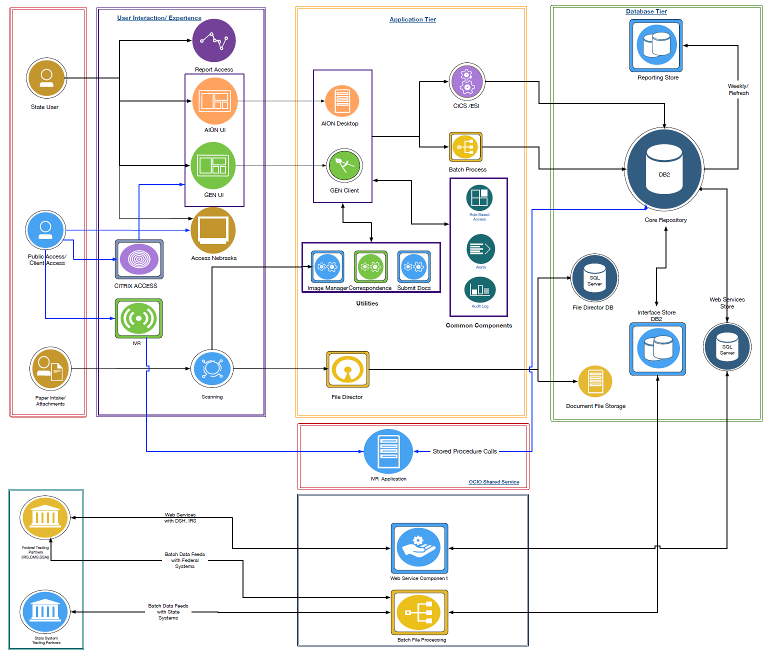

Information Security Architecture Overview
N-FOCUS contains information that is highly confidential and sensitive in nature. N-FOCUS security architecture is based on a layered model incorporating security controls in each layer.
The security in each layer includes:
- Workstation/LAN security components
- Authentication by unique user id and passwords – standard Active Directory logon scripts and network access security
- Physical security of workstations
- Server security components
- Application/Host security components
    - Application security is based on IBM’s Resource Access Control Facility (RACF) security systems. Each user is uniquely identified to the individual applications by dedicated representatives from the State, County, or office security administrator using unique user id and passwords.
    - Access to cases, reports, and data is based on a pre-assigned user authority profile that restricts access to individual programs, reports, and data on the host.
    - Access logic is part of the application program logic.
    - Relational Database Management System (RDBMS) security – Runtime client encryption and user authentication
    - Application security – Assigned security levels
    - Data access security – Assigned by authorization level, views, and profiles
    - Network security components/encryption
    - Remote access security – Currently, remote access is supported via dial-up circuits or VPN. Security is enforced through user IDs and passwords. Since access to most of the N-FOCUS environment is made available to remote users via CITRIX, the CITRIX security system is layered on top of other controls for user’s access.
- Logging and tracking
    - Invalid user IDs and passwords, as well as login attempts, are tracked in a security log
    - All user access to systems, including inquiries
    - Logs are reviewed periodically by security administrators based on local policies
    - Automatic revocation of user IDs and passwords after a predefined number of failed attempts
- Data backup and recovery
    - Data are backed-up daily on the host and the local application servers (local user files)
    - Tapes at the data center are moved off-site on a daily basis
- Physical security
    - Access to the data center is controlled by access badges
    - Servers are placed in locked rooms (policy)
    - Servers (in dedicated environments) have case key locks
- Security Management - Each office has a security manager responsible for:
    - Managing user IDs and passwords (add, change, delete, reset, etc.)
    - Managing access control and authority levels
    - Managing email security
Large legacy systems evolve over time to use various architecture patterns to deliver applications and solutions to the core and expanded base of end-users. N-FOCUS has over its life cycle been consistent with this development and deployment model. Any modernization project will need to revisit these architectural patterns to determine migration strategies to enable modularization, improved user experience, higher flexibility, responsiveness and scalability. An inventory of key technology and application components to be reviewed in support of delivering new business capabilities includes:
- Core application - CICS, client access
    - 570 client procedures
    - 550 Windows code blocks, 1450 dialog boxes
    - 555 server procedures, CICS ECI calls
    - Most core application generated from CA Gen tools
- Batch COBOL
    - 660 procedures
    - 720 programs
    - 230 stored procedures
    - Custom written batch COBOL programs (does not use CA Gen)
- Code development
    - CA Gen used for a lot of functionality on the mainframe
    - Visual Studio to compile and test client-side code
    - Eclipse integrated development environment (IDE) for consumer portal and Web components
- Consumer portal for Web-based access
    - Linux and Windows operating system
    - Tomcat application server
    - MS SQL Server RDBMS
    - Eclipse IDE
    - Java Server Faces (JSF) and Facelets MVC framework
    - Confirmation email to clients from ACCESSNebraska system but not from core N-FOCUS system
- Business Intelligence (BI) reporting, dashboards
    - Crystal Reports and Business Objects Enterprise
    - Copy of Db2 data weekly for reporting
    - Business intelligence/reporting using a shadow database with minimal de-normalization (updated on a weekly basis).
        - The effort to move this shadow database to daily has been pursued but found to be cost prohibitive effective without a data warehouse.
        - Uses database utilities to maximize efficiency.
        - No attempt to filter for only current or changed records.
        - Most reporting are batch run reports available to users from the Business Object enterprise report server.
    - There is minimal ad hoc reporting available.
    - Some reports pushed to web for general access
        - There is no N-FOCUS data warehouse for trending and forecasting, however N-FOCUS feeds data to the MMIS Data warehouse at Thompson Reuters for trending and forecasting.
- Data management
    - Db2 version 12 on z/OS
    - Over 650 tables (300+ tables are code tables that are copied to local file servers for screen edit support).
    - Large portions of this data are copied weekly to a shadow database for reporting purposes.
    - Access to Db2 via CICS transaction monitor
    - Some data are kept in MS SQL Server RDBMS for content indexes and working data on web servers.
    - There is no archive or sunset policy applied to N-FOCUS consistently leading to constant data storage growth. Archive capabilities are available and used on parts of N-FOCUS
    - 785 relationships 1278 indices, 9665 attributes(columns)
    - 1.6 Billion rows of data, largest table 206 million rows
- Business rules engine
    - AION Rules Engine – Used in limited functionality and not implemented properly to enable fully automates application of benefits eligibility rules
    - This technology component is considered high risk due to limited market reach for this tool and insufficient continued investment by Broadcom
- Content management
    - Currently, content is stored in a FileDirector document management environment
    - Currently, most content is incoming documents that are scanned and tagged.
    - Internal and outgoing documents are captured and stored in the N-FOCUS database correspondence system.
    - SharePoint is used primarily as a document repository for development team support and user instructions.
- Access technologies
    - Remote Access by personnel and contractors is enabled by using CITRIX.
    - Web-based consumer access has limited functionality for capture of benefits application
    - Agency Desktop users access the system directly via the state network.
    - Call in clients use interactive voice recognition (IVR) which is connected to N-FOCUS for client information popup
    - Change/Build/Release processes and frequency are well-managed and are usually on a 3 cycles per year schedule
    - Near-real-time nature of all transactions for programs within N-FOCUS (very little batch or overnight processing required for key business functionality).
    - Highly integrated data and functionality across most HHS programs
        - Separating out any sub-part of this system without appropriate integration can potentially negatively impact workers. For example, splitting out the eligibility determination to support HHS and Comprehensive Child Welfare Information System (CCWIS) functionality is conceivable but will remove functionality that is working and effective today without appropriate levels of integration between the new and the existing environment
        - Common functions and data leveraged across programs.

Current Data/Information Architecture
The core data model for N-FOCUS contains the basic structure for DHHS program support. Since N-FOCUS supports as many as 30 different programs, the program management part is essentially the view that drives performance and budgetary decisions. The system was established with a household view for case management. This flexible model allows for persons to be involved in multiple households, families, and cases. The core/shared subject areas are used across all programs. In this shared model, (for example) an address change or family addition “known” to one DHHS program can be “known” to the benefit of all DHHS programs, or the birth or death records verified by one program can be pre-validated by other programs. Sharing of income records by person and family eases the discovery process.
- Core Data Model

Core Technical Challenges and Considerations for Modernization Planning
Barriers inherent within the existing architecture of N-FOCUS include, but are not limited to:
- There is no formal “control” layer to act as an intermediary between the graphical user interface (GUI) layer and the data layer to provide notifications about changes to the data/views. Rather, the GUI layer incorporates this logic, which results in a tight coupling between business rules, user interface logic, and data. This tight coupling reduces flexibility and impairs the ability to alter business rules and data structures due to the needs of changing law, regulation and policy.
- Each business process is mapped to a long series of transactions which are executed either in parallel or sequentially as individual transactions. No true system management of business processes is possible in such an environment. In the N-FOCUS architecture, a transaction may also encompass many business processes, which results in application code interdependencies that limit the ability to easily support business and program changes.
- No clear separation exists between business and user-interface logic on the workstation. This constraint limits the ability to customize the software to Partner-specific requirements.
- The existing design accesses all the case data at the workstation and does not make this information accessible outside the workstation (such as via mobile devices). With this design, information cannot be made available anywhere, anytime.
- N-FOCUS uses an approach to business rules that limits support of any strategy involving moving some core business logic to other platforms like web or mobile devices.
- N-FOCUS uses a code generation product toolset (CA Gen) that, while capable, has been deployed in such a way that business logic is spread between Db2 stored procedures, CICS access transactions, and client code running on workstations. The distribution of logic makes updates very time consuming and labor intensive to build, verify, test, and deploy.
- Custom building of every interface increases the cost to allow partners or pilot sites to exchange data. This approach has partners entering data directly into N-FOCUS via CITRIX access in addition to entering the data into their own computer system. This limitation causes data entry delays, data quality and data reporting inconsistencies. For each partner, this effort is costly and prone to increase cost for partners to participate.
- The reporting architecture uses a copy of production data copied weekly. Batch reports are generated against that copy. This is a costly approach to providing access to data, has limited the ability to generate ad hoc reports by users, and has impacted the ability to produce real-time statistics for case workers, supervisors or managers. Daily reports are generated by writing stored procedures and the output is used by Crystal Reports to generate the report. There is limited ability to forecast real-time impact of daily changes.

